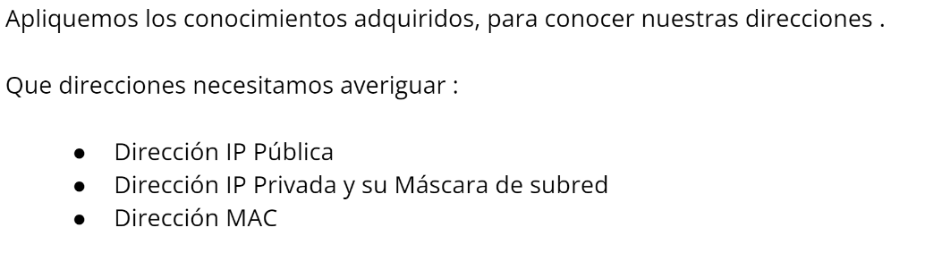

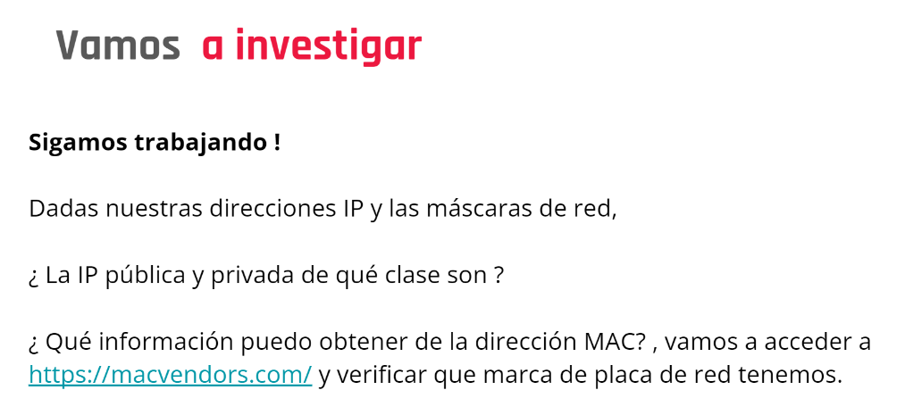

Direccion IP: [168.197.200.64](https://www.whatismyip.com/168.197.200.64/) – Clase B

IP Privada: 192.168.0.102 – Clase C

Máscara de subred: 255.255.255.0

MAC: 68-54-5A-49-DC-57 <https://ipaddress.standingtech.com/online-ip-address-class-finder-detector>

